Name ____________________. 11th February

LO Can I investigate if materials are absorbent?
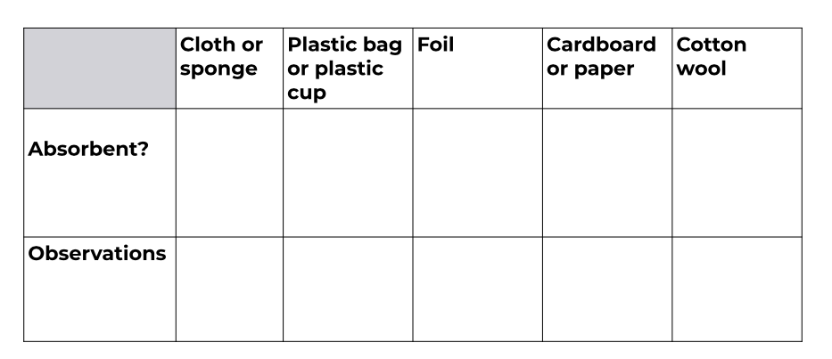
What was most absorbent? ______________________. What was least absorbent?

