Howard park community school
  - English Task Booklet – Part Two
W/C: 8th February 2021

Please find attached resources to go with the lessons for the second week of our topic

Year Two

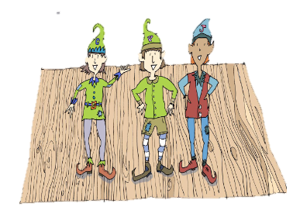

Watch and listen to the video

Find it at: https://www.bbc.co.uk/bitesize/topics/zkgcwmn/articles/zd72scw

Monday 8th February 2021
Day six

Adjectives are used to describe a noun. Adjectives can be colours, shapes, sizes, textures or personality traits (kind, mean, caring).

Expanded noun phrases use two adjectives to describe a noun. We must remember to use a comma , between the adjectives. Try to remember:

adjective , adjective noun

e.g., the small, tired boy the angry, red gnome

This week we are going to plan and write our own story based on The Elves and the Shoemaker. Your task today is to create your own elf for your story.

Try and include adjectives in your design.

- Create and design your elf.
- Name your elf.
- What is your elf helping make? Is it clothes? Is it an object?
- Add adjectives to describe your elf.
- Add expanded noun phrases to describe your elf.

Use the template on the next page to create your elf. Miss Guy has added her elf below to give you some ideas.

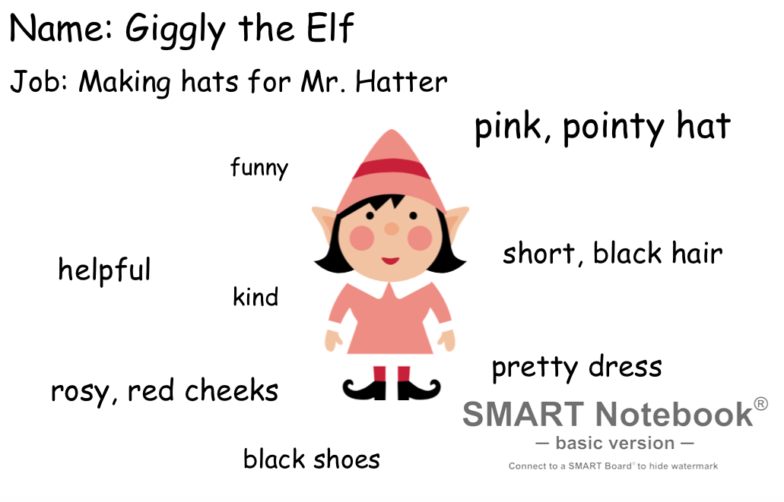

Things to remember when describing your elf:

- What are their clothes like?
- What are their shoes like?
- What kind of elf are they? Are the kind? Are they caring?
- What is their hair like?

Remember to use amazing adjectives – maybe google some better adjectives or use a thesaurus. If they have a big hat, could it be a huge hat? Could it be a gigantic hat?
Elf Name: ___________________________

Elf Job: Fixing _________ for __________

Tuesday 9th February 2021
Day Seven

Reread the Story

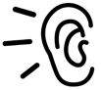
Read the story ‘The Elves and the Shoemaker’ or listen to it the author here:
https://soundcloud.com/talkforwriting/elves/s-ySTFOVAVMmH

Today you are going to plan your own story based on the elf you created yesterday and the story of the Elves and the Shoemaker. Below are the different stages of planning a story and how they link to the Elves and the Shoemaker.

Opening | We start by introducing the characters and the setting. | In the story we are introduced to the shoemaker and his wife. The story takes place in their home and workshop
Build-Up | This is where we begin the story. | The shoemaker is poor and sad. He leaves the last pair of shoes to make in the morning.
Dilemma | We need to look at the problem. | The elves make the pair of shoes and the shoemaker is very shocked. The elves keep coming back but they still do not know who it is making the pairs of shoes. People begin to buy the shoes.
Resolution | We need to look at how the problem is fixed. | One night the shoemaker and his wife see the elves. As a thank you, they make them new clothes.
Closing | We need to end the story. | The elves are happy with their new clothes and the shoemaker is no longer poor. The elves never come back now the shoemaker is happy.
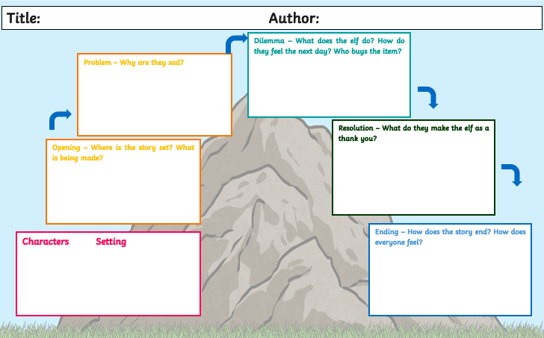

Wednesday 10th and Thursday 11th February 2021
Day Eight and Nine

Your task today is to write your story based on the Elves and the Shoemaker. Use your plan to help support you in your writing.

Try to remember to use the following:

Expanded noun phrases Adjectives Interesting sentence starters

Remember Magic 5!

Capital letters and full stops Finger spaces Neat handwriting Does my writing make sense? Have I spelt words correctly?

Use the resources below to help you write your story. There are two blank pages for you to write on if you need.

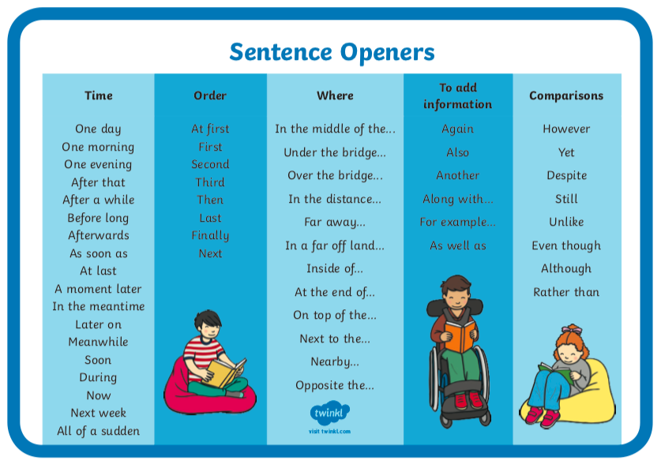

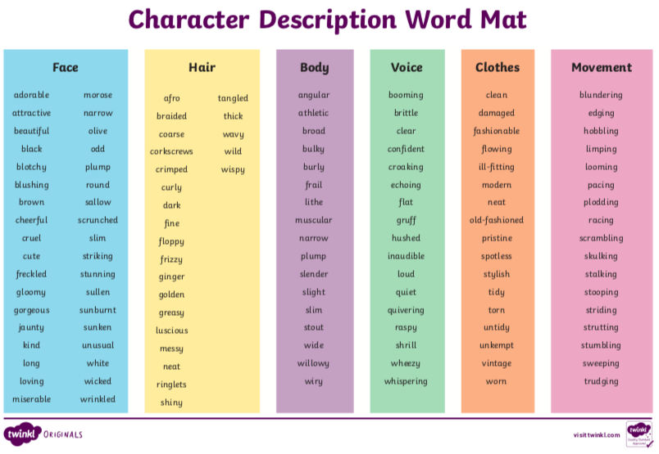
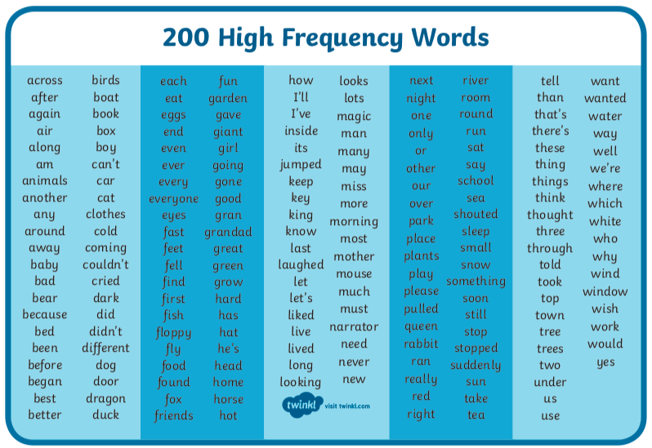

Use this space to write your story

Friday 12th February 2021
Day Ten

A green pen OR a different colour to the colour you wrote your story in.

What you will need:

Finish off writing your story and then it is time to edit and improve it.

- Read through your story. Does it make sense? Are there any words missing?

- Check for Magic 5!

- Are there any spellings that can be corrected? (Use the high frequency check list to help you)

- Can you add any interesting sentence starters?

- Can you add more description? (Use the adjectives check list for extra support)

After you have edited and improved your work you could add illustrations to your story to make it into a book!

How to Edit and Improve your Work

