Camels Come Dancing Animation
https://scratch.mit.edu/projects/472424495

Have a go at creating your own animation like this one. You can change the Sprite to something different but you should still have the same concept at the end.

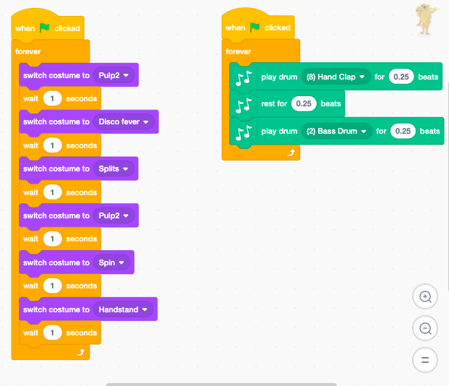
Using the link above, you can ‘See Inside’ the animation and copy the code on to your own creation or I have copied it here for you to see.
You can change the order of the costume changes and how long the wait is in between.

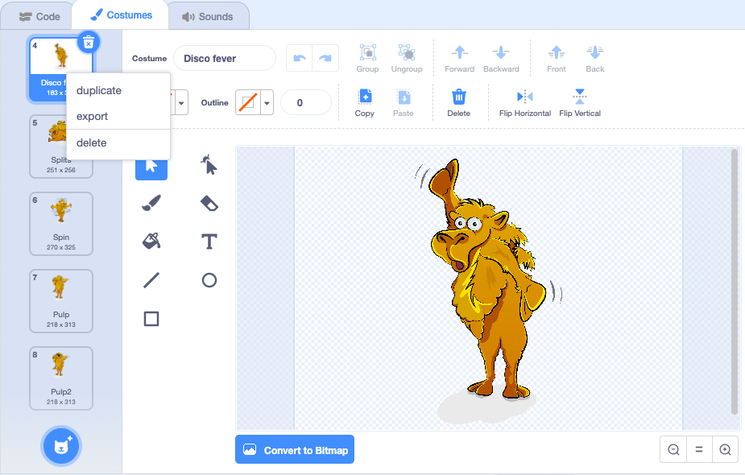
If you can, I would also like you to add in a costume of your own. I made ‘Pulp2’ by duplicating ‘Pulp’ and drawing on some sun glasses. You can do something similar, depending on the Sprite you choose.

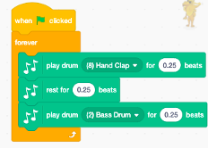
The music code can also be changed. This is a new feature on Scratch and you need to click on the icon at the bottom left to add it in.

Play around with it and add different instruments in to create some music for your Sprite to dance to.

