Wednesday 3rd March 2021
Day eight

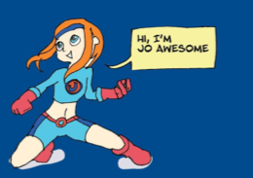

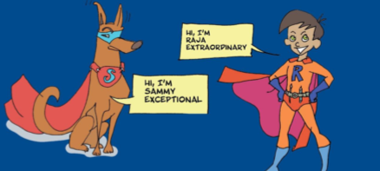

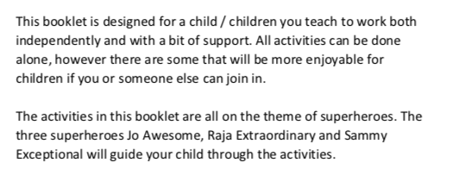

wednesday 3rd March 2021
Day Eight

Today we would like you to come up with a Superhero pet like Sammy.

Can you draw and label your superhero pet? Can you come up with a superhero name for your pet?
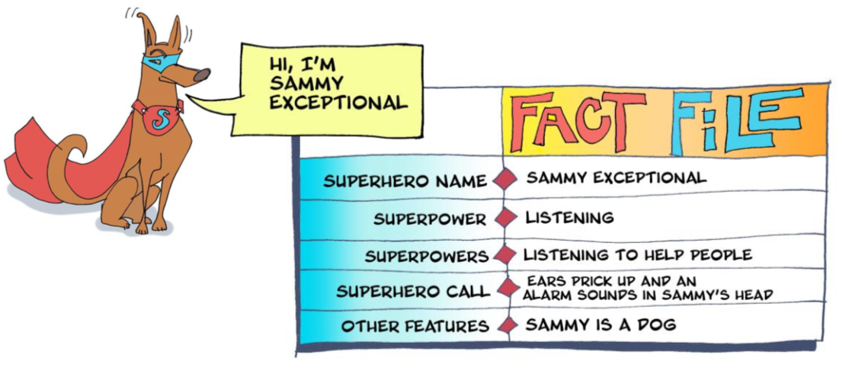
Draw and label your superhero pet in the box below;
Can you draw and label your superhero pet? Can you come up with a superhero name for your pet?

Complete this fact file on your superhero pet;
