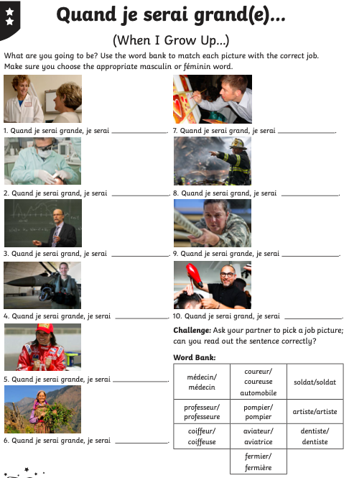
Look Back through the presentation if you need some help.
Now write a sentence about what you want to be when you grow up. Use an online French dictionary to help you.

