Tuesday 2nd March 2021
Day seven

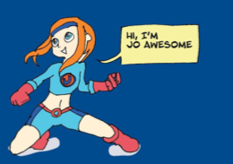

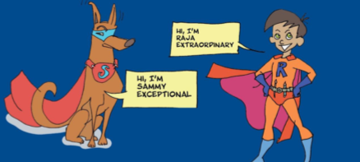

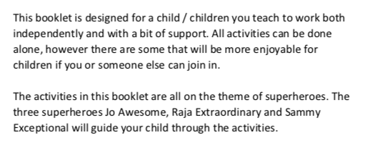

Tuesday 2nd March 2021
Day seven
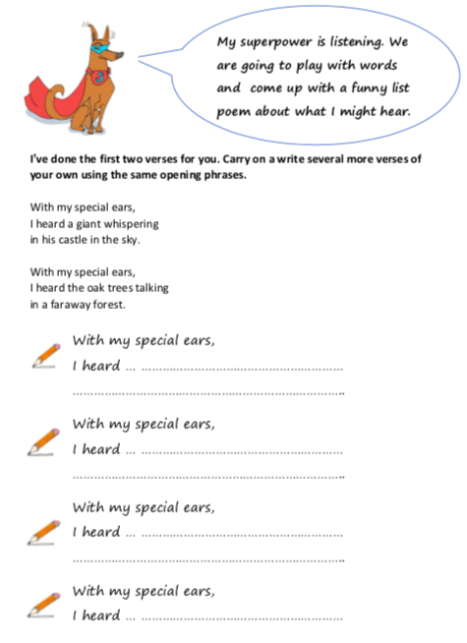
Watch the clip on How to Write a Poem; https://www.bbc.co.uk/bitesize/topics/zjhhvcw/articles/zg6dng8

