Name ________________________ 4th March 2021

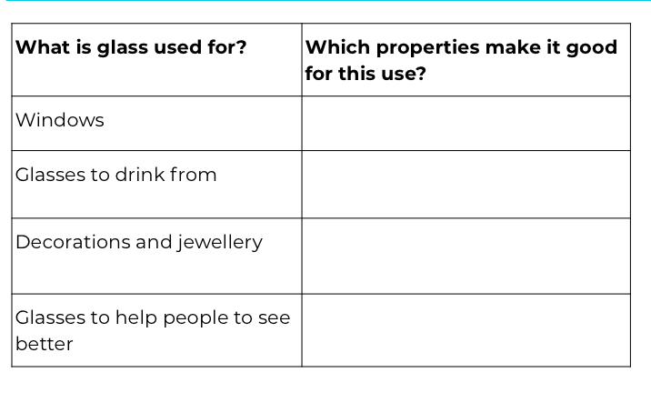

What is plastic used for? | Which properties make it good for this use?

