Thursday 25th February 2021
Day four

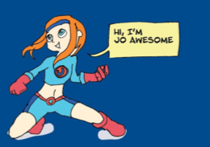

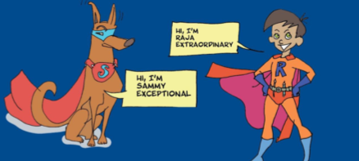

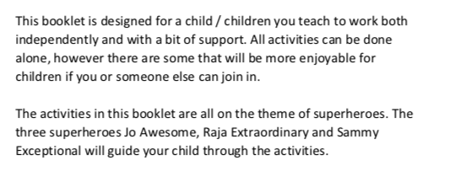

Thursday 25th February 2021
Day four
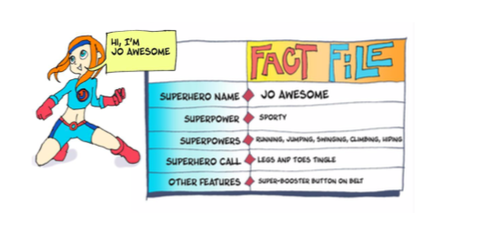
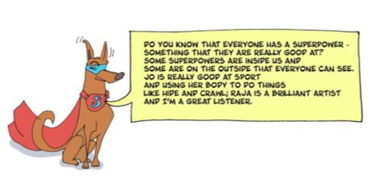

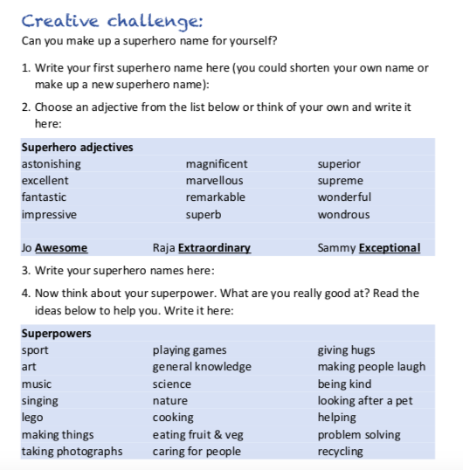
Watch this clip; https://www.youtube.com/watch?v=ZgCogMNoj9o

Draw yourself as a Superhero here;

Can you use expanded noun phrases to label and describe?
For example;
-red, long cape -enormous, metal rocket boosters

