thursday 4th March 2021
Day nine

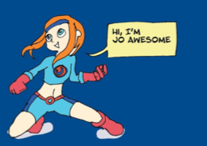

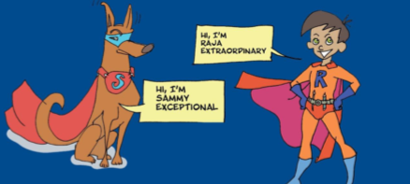

thursday 4th March 2021
Day nine
Watch the clip. It talks about inference and understanding what is happening in a story or text; https://www.bbc.co.uk/bitesize/topics/zs44jxs/articles/zqmyw6f
Below there are three short passages of text each with a set of related focus questions.
These activities contain six questions in total that begin to work on higher-order reading skills with questions that are displayed using different formats (e.g. multiple choice, find and copy, ranking/ordering).

