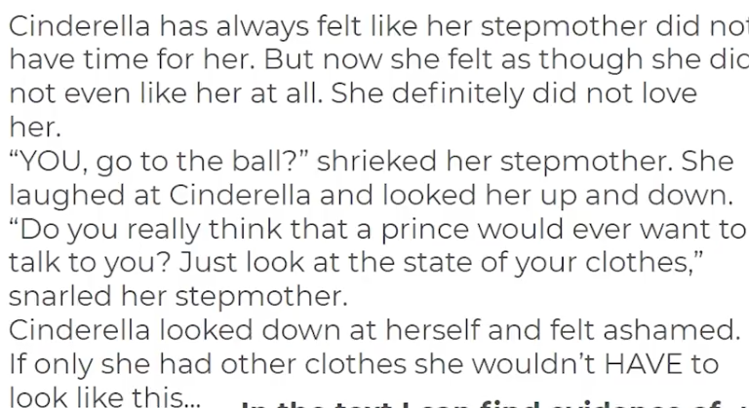

Copy the beginning of the following sentences and complete them using the text above.

In the text I can find evidence of a difficulty when…

In the text I can find evidence of consequences when…

In the text I can find evidence of thoughts and feelings when…

In the text I can find evidence of learning for the world when…

