Monday 8th February 2021
Choose 3 fruits to fill in on the tally chart.
Draw next to each child below what his or her favourite fruit is.
Then complete the tally. You can add yourself and anyone in your house if you want.

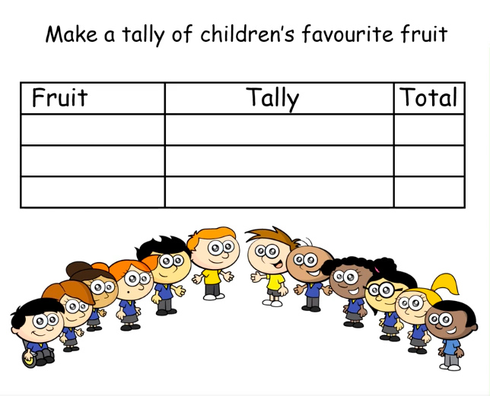
Which are the most and least popular fruits?

Now have a go at creating your own tally chart.
Some ideas for the topic:

- Traffic passing your house.
- Types of food in the cupboard e.g. bottles tins packets etc
- Toys, games , books you have.

Can you say some information from your tally chart?

