Homophones
- Here are a set of homophones (words that have the same sound but a different meaning). Can you find out what each one means and then put it into a sentence.

- Here are some sentences that are missing some words. All the words that are missing are homophones. Can you complete them with the correct word from the list at the bottom.
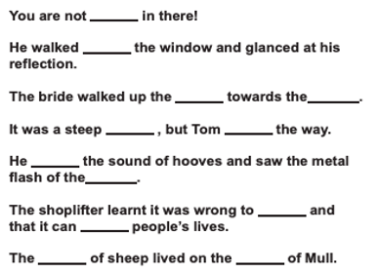

allowed
aisle
alter
know
past
ascent
heard
herd
bridle
affect
steal
isle

