Monday 29th December 2021
Plants – What types of plants grow in the wild?

LO: I identify and describe flowers that are found in the wild.
LO: I can different wildflowers.

- Draw a picture of what your bean plant looks like now

- Draw a label the 5 different wild flowers.
______________________ |  | _______________________
______________________ |  | _________________________
 | __________________________

- Wildflowers provide a habitat for lots of ______________.

- Wildflowers help keep __________________ healthy.
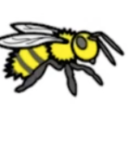

- _________________ need flowers for their pollen.

What wildflowers have I found?

