Monday 1st March 2021
Day six

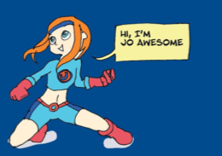

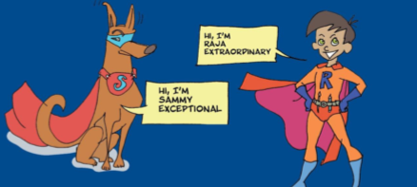

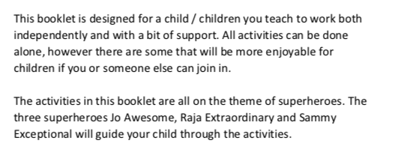

Monday 1st March 2021
Day six
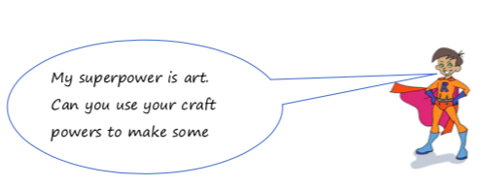

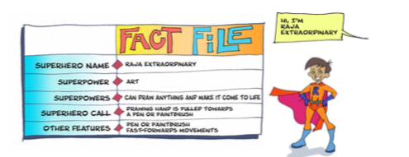

Watch the clip; https://www.bbc.co.uk/bitesize/topics/zgqxwnb/articles/zfrcmfr
Read and follow the instructions on the following pages to make your own set of Superhero Cuffs. You will need a toilet or loo roll…
How to make a pair of Superhero Cuffs

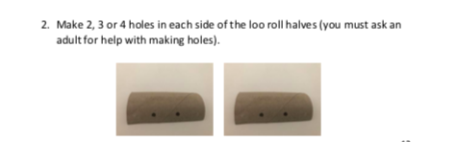
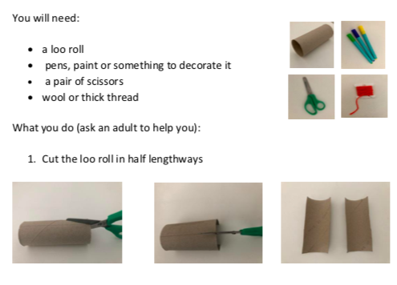

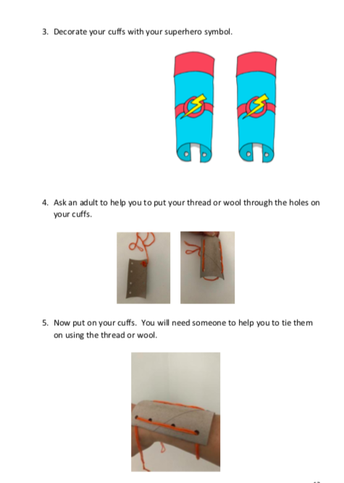

6. Put your Superhero Cuffs on and feel like a real Superhero! How do they make you feel?
As an extra challenge why don’t you write your own set of instructions which show how to make a Superhero face mask?

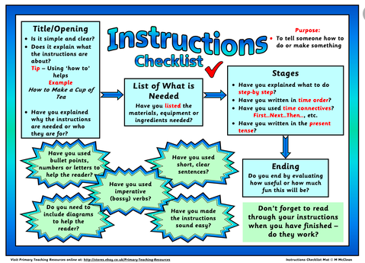
Why not try reading more instructions and create more superhero crafts as and when you have time…

