Friday 5th March 2021
Day ten

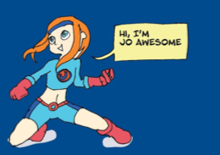

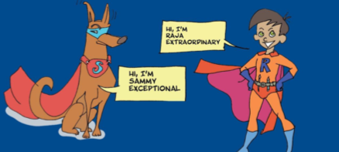

Friday 5th March 2021
Day ten
Invention Time
Today we would like you to write a superpower rescue challenge all of your own.
Watch the clip; https://www.bbc.co.uk/newsround/34759926
https://www.bbc.co.uk/bitesize/topics/zkgcwmn/articles/zbk47nb

You could use the original Playground Rescue story or The Adventures of Blueberry Boy to help you. You may want to magpie some ideas! Use the superhero character you based yourself on, could you also include the pet superhero you created too? Could you draw the story as a cartoon? We have included a cartoon strip for you to use…Draw pictures and write sentences in each box. Can you use speech bubbles for characters speech?

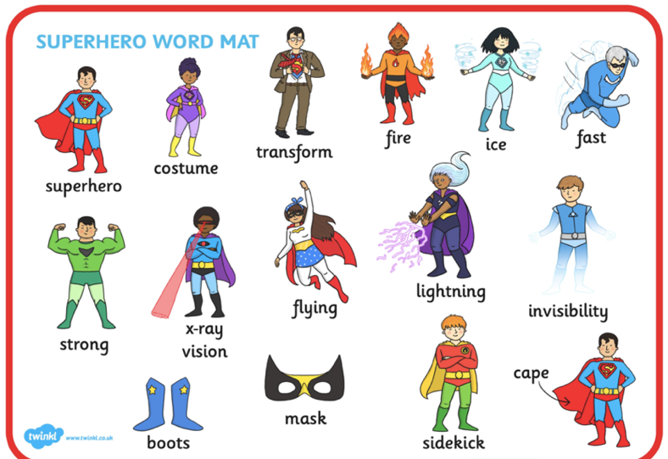

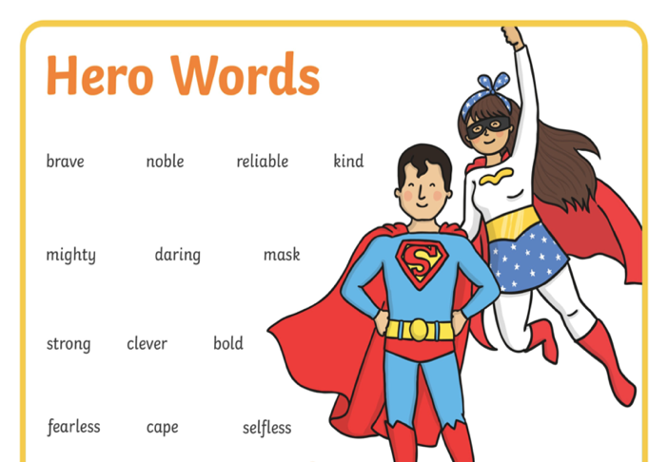

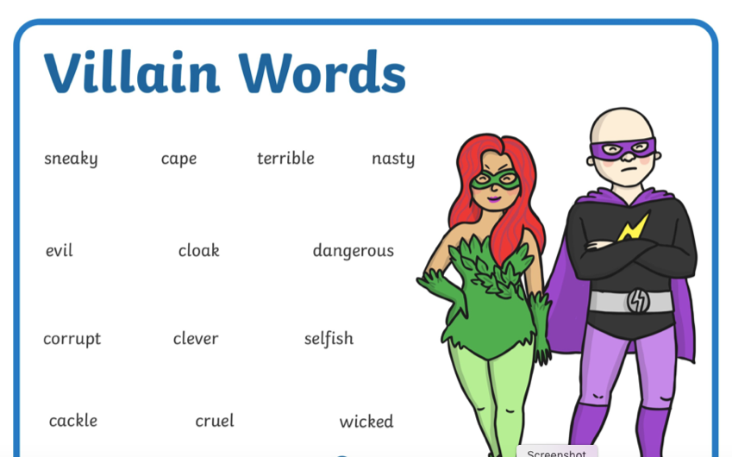

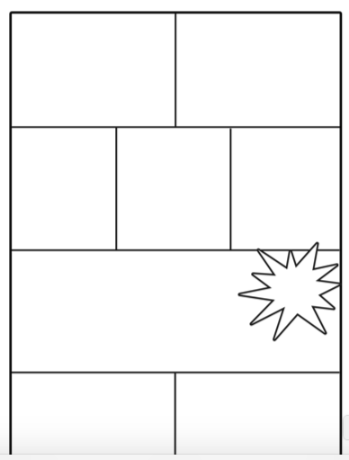
You can use this comic strip or create your own;

