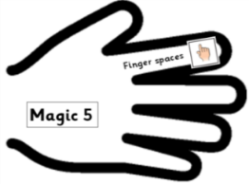 | Date: Tuesday 2nd March 2021 | SA
 | L.O. To explore expanded noun phrases (2A phrases).

Spot the expanded noun phrases (2A phrases) in each of these sentences and underline them:
- The frothy, white waves splashed against the boat.

- As Fausto sailed across the clear, sparkling waves, he thought about all that he owned.

- The hot, midday sun shone high above the sheep and the tree.

Add your own adjectives to complete the expanded noun phrases in following sentences. Remember to use the most descriptive vocabulary you can! Use an online Thesaurus to help you make more descriptive word choices:
- Fausto stepped out into the __________ , ___________ boat and set out to conquer the ____________, ____________ sea.

- As he sailed out across the water, __________ , _________ puffs of smoke drifted into the ____________ , ____________ air.

- The ___________ , ___________ waves _______________.

Can you write 3 of your own sentences about the story which include expanded noun phrases:

- _____________________________________________________

_____________________________________________________

- _____________________________________________________

_____________________________________________________

- _____________________________________________________

_____________________________________________________
English Tuesday 2nd March Continued:

Challenge:
Complete these sentences from the video adding further description and expanding the noun phrases in different ways (using ‘with’ or describing where the noun is):
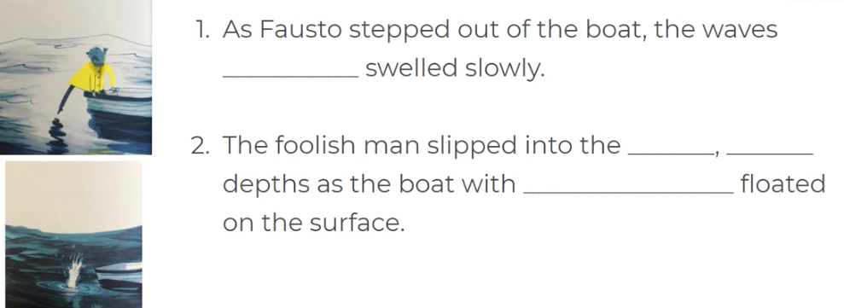

Use the ‘Constructing an expanded noun phrase’ word mat and your own ideas to make at least 3 of your own sentences below (do more if you like!) e.g. The fiery, ugly troll beneath the bridge.

