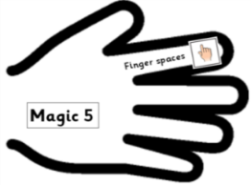 | Date: Tuesday 9th February 2021 | SA
 | L.O. Can I write the first section of my explanation text?
Success criteria: |  | SA
Can I use Magic 5 (non-negotiables)?
- Have I used causal and sequencing conjunctions?
- Have I used technical language and synonyms, e.g. process, creatures?
- Have I used ENPs (expanded noun phrases) to add detail (2A – adjective, adjective, noun)?

