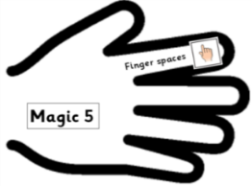 | Date: Monday 1st March 2021 | SA
L.O.
To read, discuss and understand the fable ‘The Fate of Fausto.’
To explore word classes.

KEY: (choose a colour for each so you can identify and shade each word class in the sentences below)
Noun
Verb
Adverb
Adjective

Colour the noun, verb, adverb and adjective in each of these sentences:
- The selfish man angrily stamped his foot.
- The huge mountain listened calmly.
- The helpless flower replied softly.

Add your own adjectives, adverbs and verbs to complete the following sentences. Remember to use the most descriptive vocabulary you can! Use an online Thesaurus to help you make more descriptive word choices:
- The ______________ man _______________ impatiently to the sea.
- The ________________ , _________________ sea listened ________________ to him.
- He began to sink as he stepped _________________ out of the _________________ __________________.
- The ____________ man began to ____________ _____________ because he did not know how to swim.

Can you write 3 of your own sentences about the story, including nouns, adjectives, verbs and adverbs:
- _____________________________________________________

- _____________________________________________________

- _____________________________________________________

