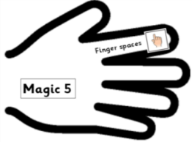 | Date: Monday 8th February 2021 | SA
 | L.O. Can I write the introduction for my explanation text?
Success criteria: |  | SA
Can I use Magic 5 (non-negotiables)?
- Have I used a question and ‘read on…’ sentence?
- Have I used technical language and synonyms, e.g. process, creatures?
- Have I included an interesting fact?
- Have I used exciting adjectives?

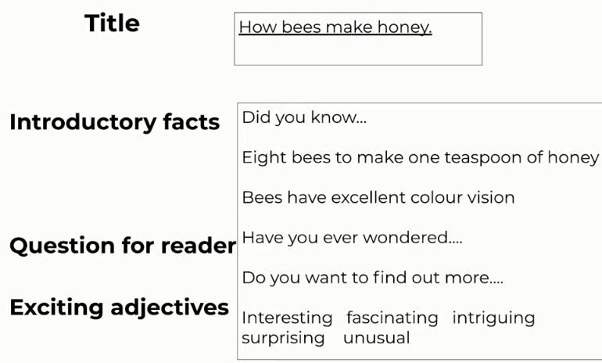
Remember:

______________________________________________

