Year 2 English
Wednesday 27th January 2021

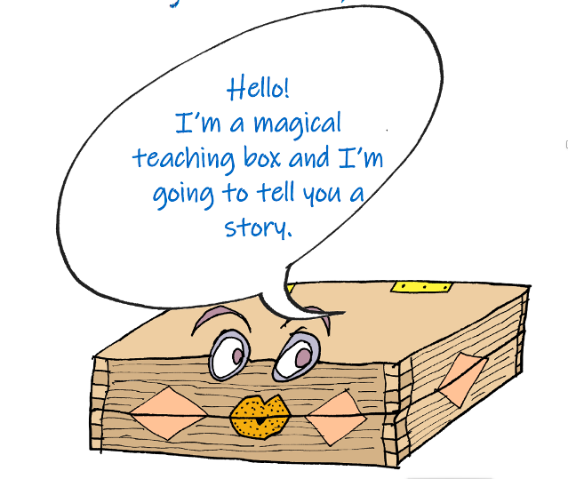
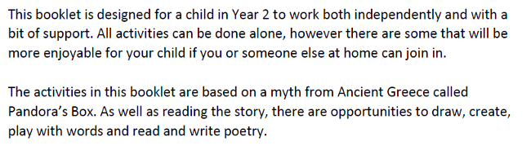

Apollo was also the Greek god of poetry. Let’s do some poetry activities together! Start by sharing this poem with someone at home.

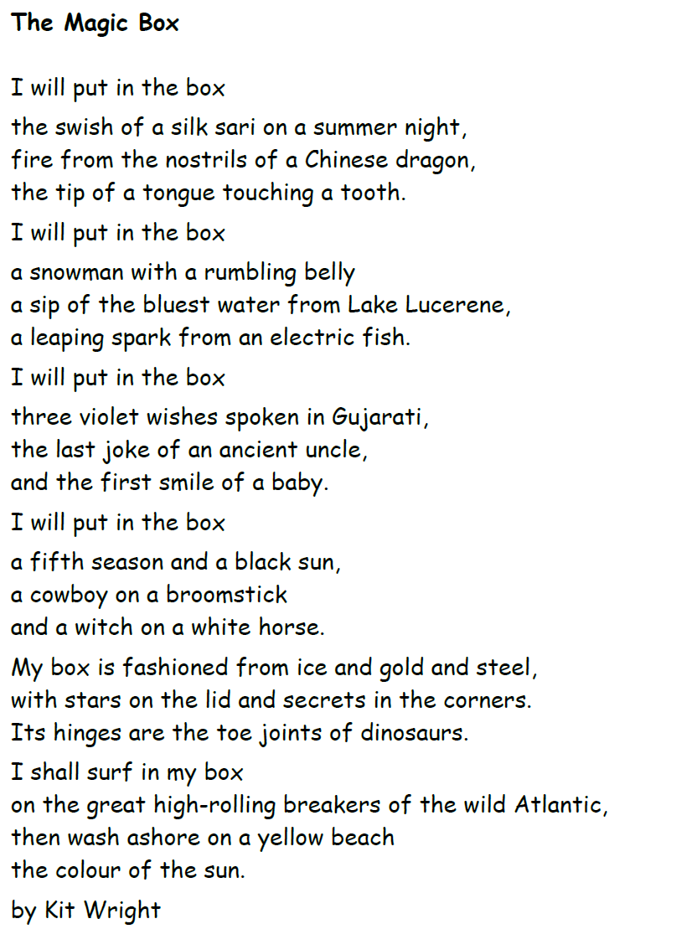

If you have a computer, you can listen to Kit reading his poem:

https://www.bbc.co.uk/bitesize/clips/zkpmhyc

Talk about the poem and write your ideas here: 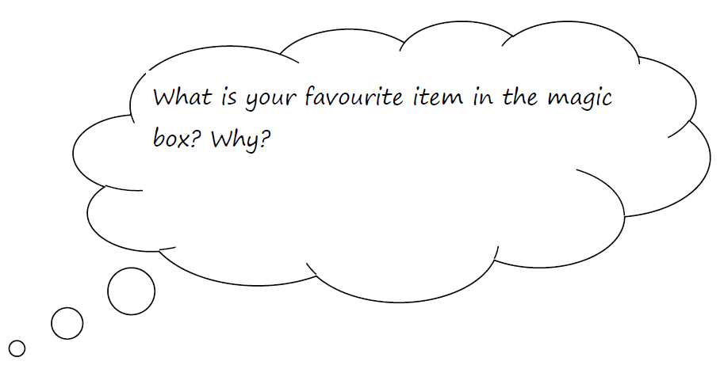

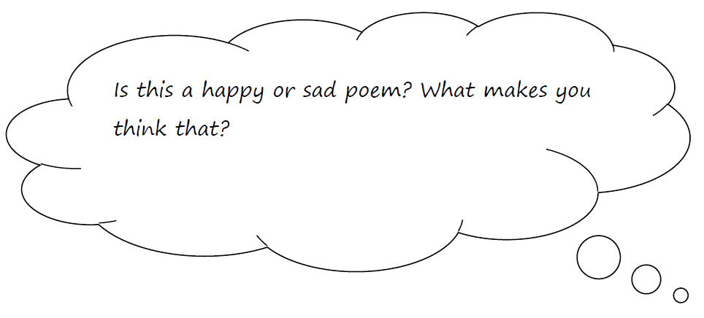

It’s time to get creative!

