Comment me décrire ? (What Do I Look Like?)

Couleurs des cheveux (Hair colour)
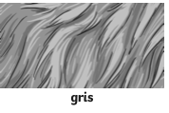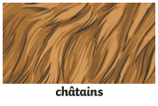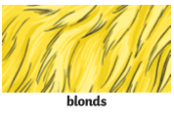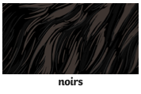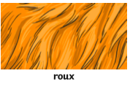

Longueur des cheveux (Hair length) Les coiffurs (Hair style)
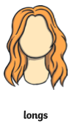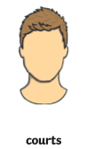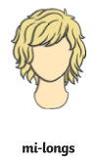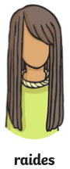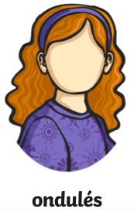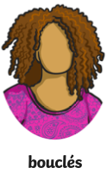

Couleurs des yeux (Eye colour)
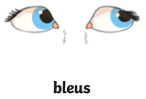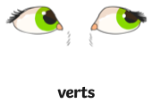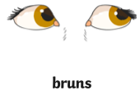

Complete the sentences by filling in the gaps.

- J’ai les cheveux courts.

I have _________ hair.

- J’ai les yeux verts et les cheveux bouclés

__ _____ _______ eyes and _______ ______.

- J’ai les ____________ ______ et ____ _______ _______

I have blonde hair and brown eyes.

- ____ ___ _________ _____ et _______ et ____ _____ _______.

I have grey and curly hair and green eyes.

Now write some of your own sentences using the information at the top of the page. You are writing in the first person but they can be totally made up.

