Year 2 English
Tuesday 26th January 2021

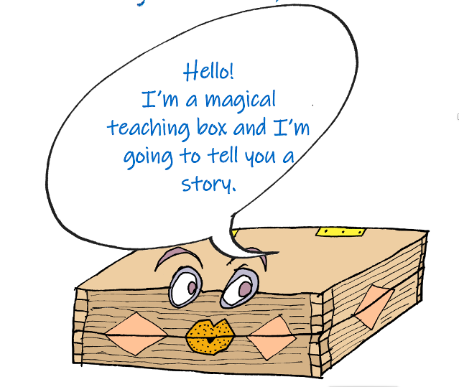
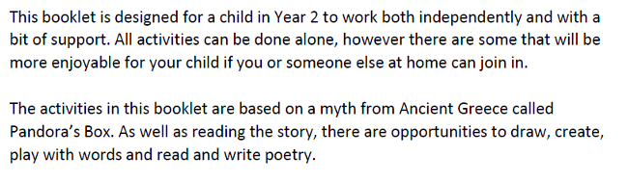

Can you read this?

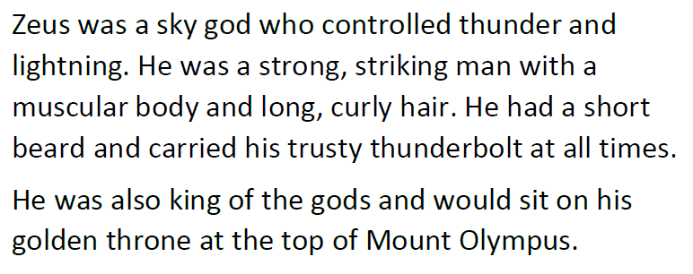

Can you draw Zeus and label his features?

Can you answer these questions about the story in complete sentences?

Read the story again to help you.

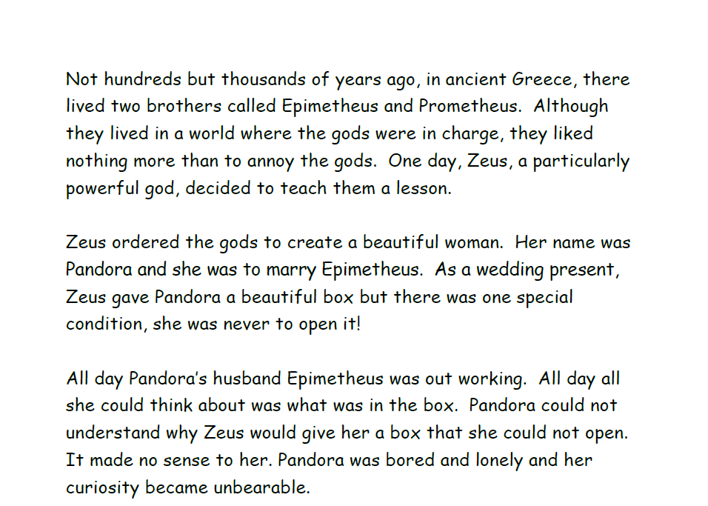

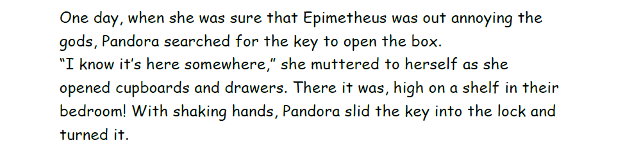
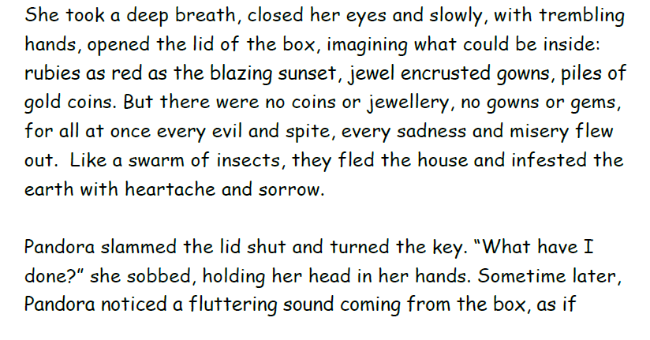
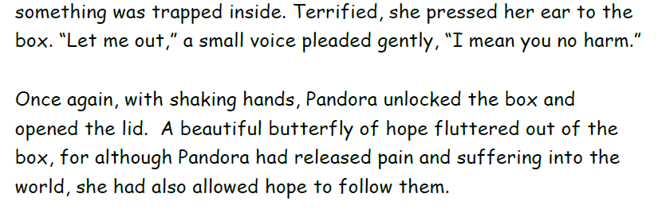
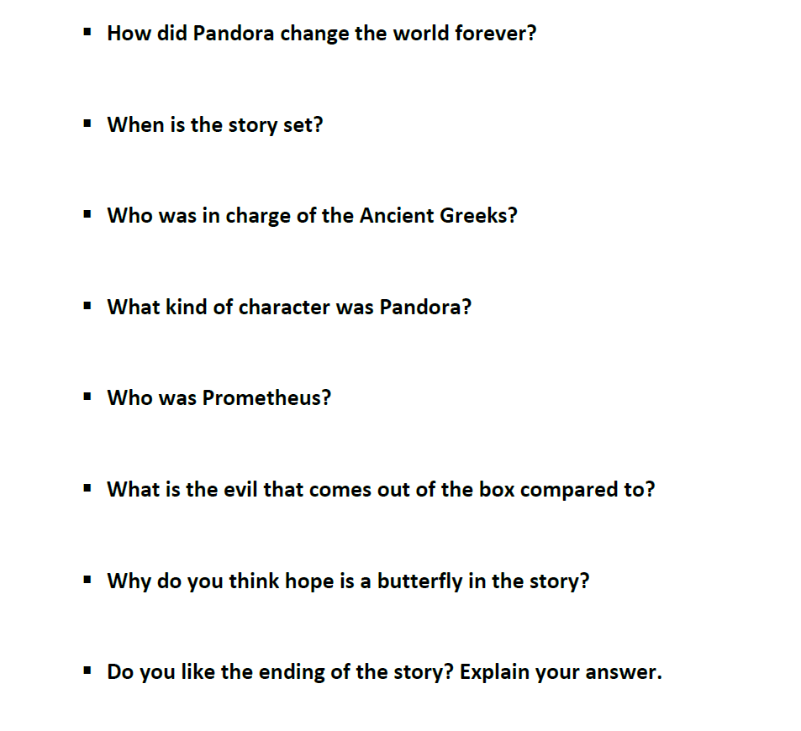

Now, match the word to its meaning in the story – one has been done for you.

