Year 2 English
Thursday 28th January 2021

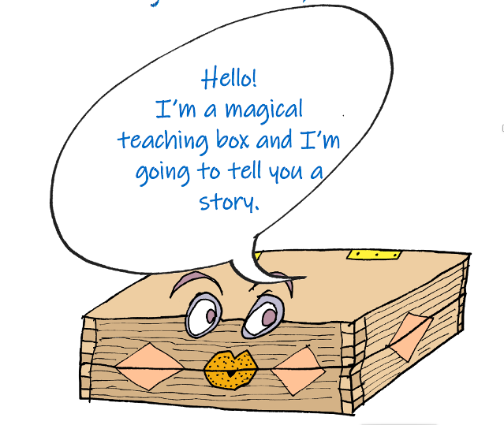
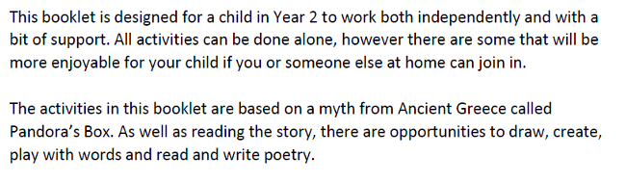

Your box is magic, which means you can put anything you like in it.

Start by writing a list of your favourite things, people or places

