Date: ________________________  L.O. Do I understand the difference between night and day? | SA: | TA:

- There are ________ hours in a day.

- When we face towards the sun it is _____________________________________________.

- When we face away from the sun it is ___________________________________________.

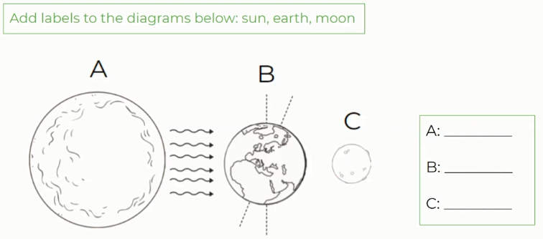

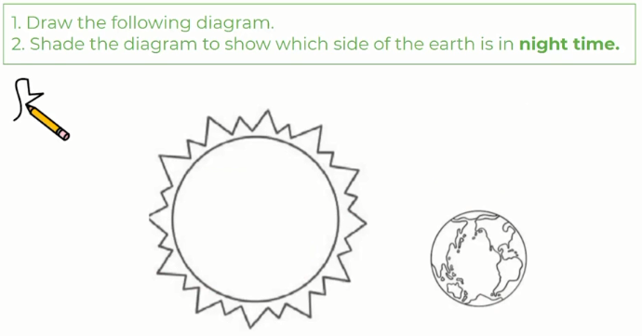

Here is my picture to show how I think life on Earth would change if there was no sun:

