Weather Forecast
LO: To observe and describe weather associated with the seasons by observing and recording the weather in winter.
Cut and colour in the weather symbols
Use these to tell the weather as weather forecaster
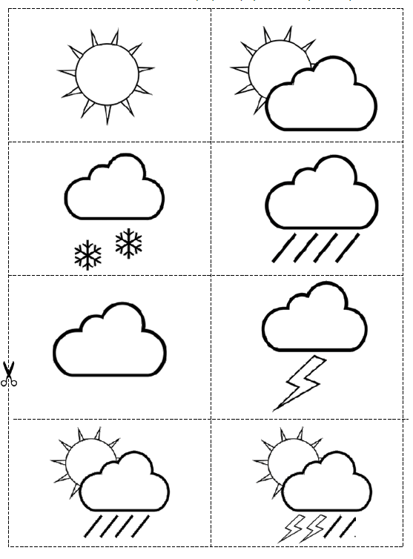

Hello everyone, today’s weather report comes from...

As you can see, the weather today is..

This morning the weather was ...

The wind is...

The sun is...

After school the weather should be...

If you are out in the playground today, don’t forget to...

Thank you for listening. And now back to...

Talking about Weather
Reporting

I’m a weather forecaster
Weather reports on the television are written by people who watch the weather and then use symbols to tell everyone.

We have watched the weather in the playground (garden). Now we are going to work out how to tell everyone about it. You will need a large map of the area where your school is and weather symbols (attached below).

Stand in front of the large map. Ask the others in the group (parents) to hold the map and the symbols.
Use these sentences to help you:

Hello everyone, today’s weather report comes from (say the name of your school).
As you can see, the weather today is (say what the weather is doing and stick the symbols on the map).
This morning the weather was (say what it was doing at breakfast time) but now the weather is (say what it is doing now).
The wind is (say what it is doing. Is it strong or light wind? Is it blowing hard across the playground or hardly there at all? Point at the map to show where the wind is blowing)
The sun is (say if it is hot and bright or covered by cloud).
After school the weather should be (say what you think it will be like at teatime. Put the symbols on the map).
If you are out in the playground today, don’t forget to (Say what you think is the best thing for the weather. Put on sunscreen and a hat? Wear a coat? Stay in the shade?)
Thank you for listening. And now back to (say the name of your teacher).
