The word sign comes from the French ‘signe’ and the Latin ‘signum’ meaning sign. These words all include the root word sign.
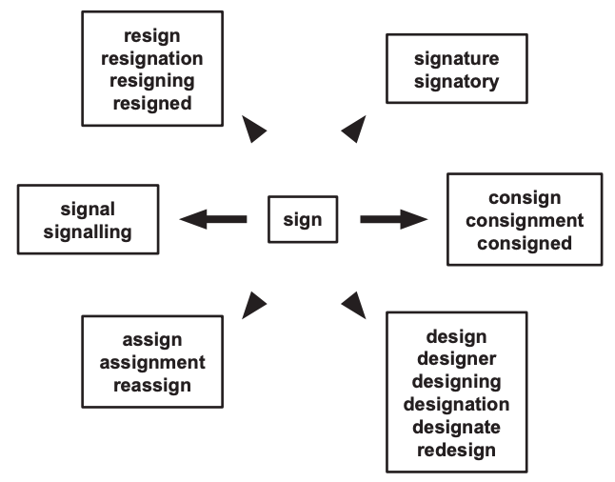

Now make a word web for the root word press (you can use a dictionary to help you)

