Learn these words with unusual spellings
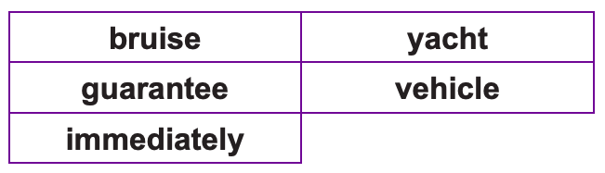
Use the same strategies we use in class
- Pyramid words
- Trace, copy and replicate
- Look, say, cover, write, check
- Drawing around the word to show the shape
- Drawing an image around the word
- Words without vowels
- Any other methods that work

