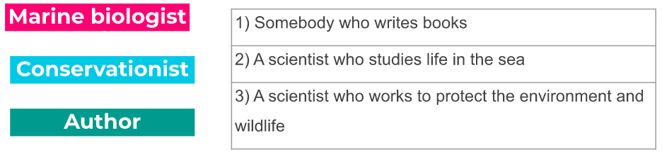

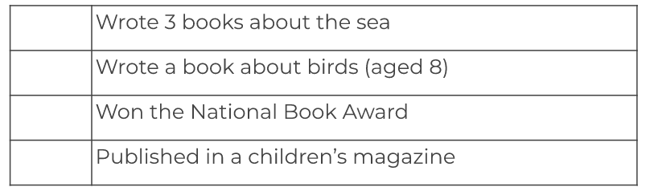

- What are some of the achievements of the Us Environmental Protection Agency?
________________________________________________________________________________________________________________________________________________________________________________________________________________________________________________________________________________________

A) What is the threat
B) Why is it important?
C) What can we do?

Dear my Local MP,
I am writing to you as a constituent because I am concerned about _____________________. Did you know that _________________________________________
____________________________________________________________________________________________________________________________________________________________________________________________________________________________________________________________________________________________________________________________________________________________________________________________________________________________________________________________________________________________________________________________________________________________________________________________________________________________________________________________________________________________________________________________
Say why they are important
Write about threats

Here are some solutions we could put in place to solve the problem: __________________________________________________________________________________________________________________________________________________________________________________________________________________________________________________________
Say what we can do about it.

I look forward to hearing from you,
Yours sincerely,

__________________________________

