Year 2 English
Monday 25th January 2021

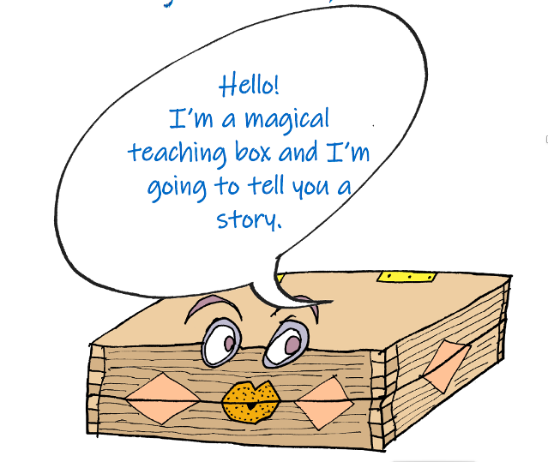
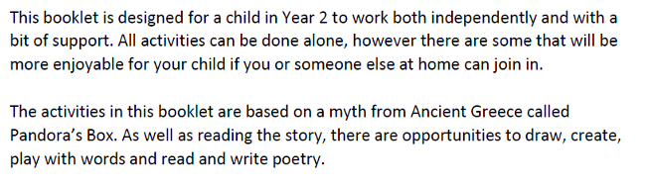

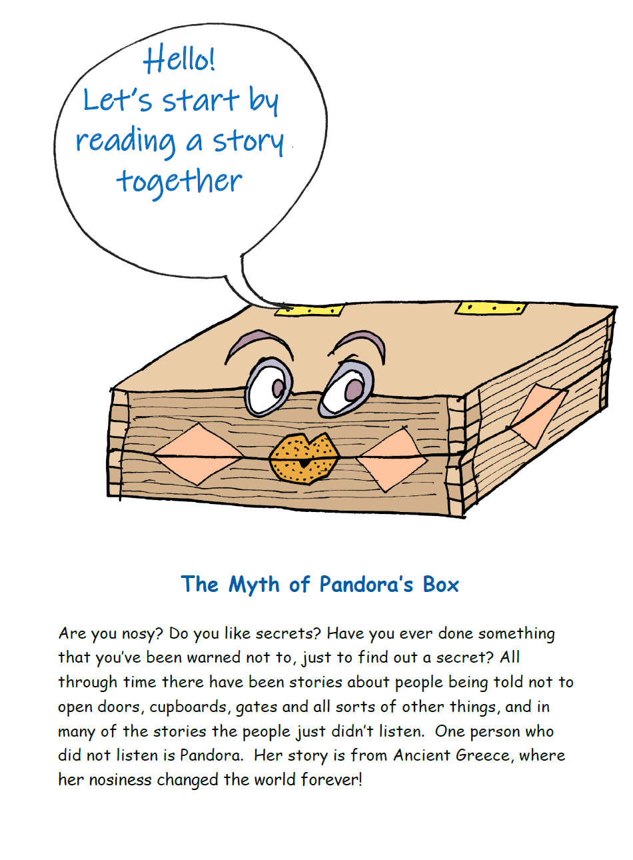

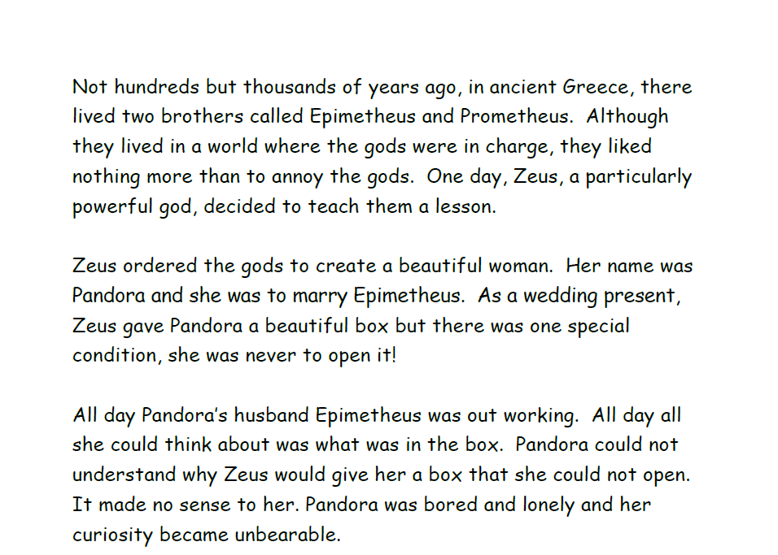

Let’s stop here and do an activity…

What do you think the box looked like? Draw it here…
Can you use any expanded noun phrases to describe it?

Let’s read some more…

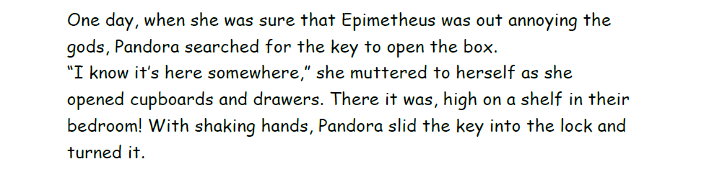

Let’s stop reading for a moment and think about what could be in the box.

Draw or write your ideas below…

Let’s read some more…

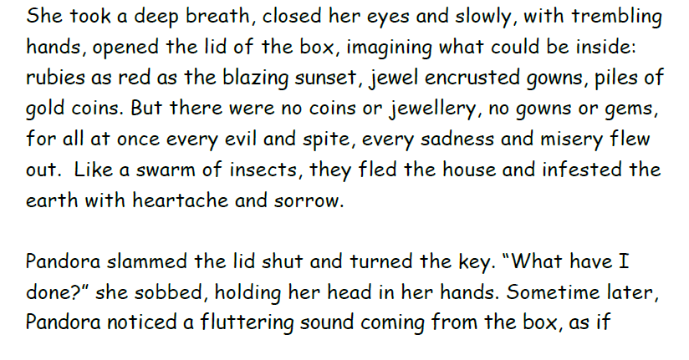

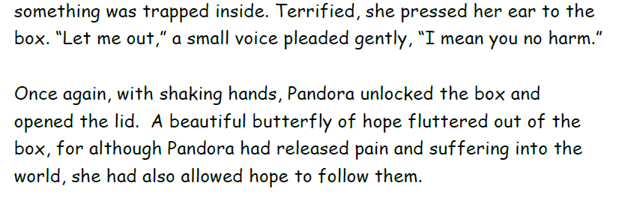

Now, draw the evil that came out of the box. One idea has been drawn for you…

