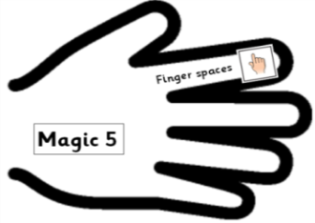 | Date: Monday 1st February 2021 | SA
L.O.
To revise word classes.
To use precise and technical vocabulary.

A noun is _________________________________________________________________
An adjective is ______________________________________________________________
A verb is __________________________________________________________________
An adverb is _______________________________________________________________

- Can you choose the appropriate adverb to go with each of the verbs on the video:
pour _________________________ seal ____________________________
suck _________________________ search ___________________________
flap __________________________

My Wordbank:
Nouns: | Adjectives:
Verbs: | Adverbs:

