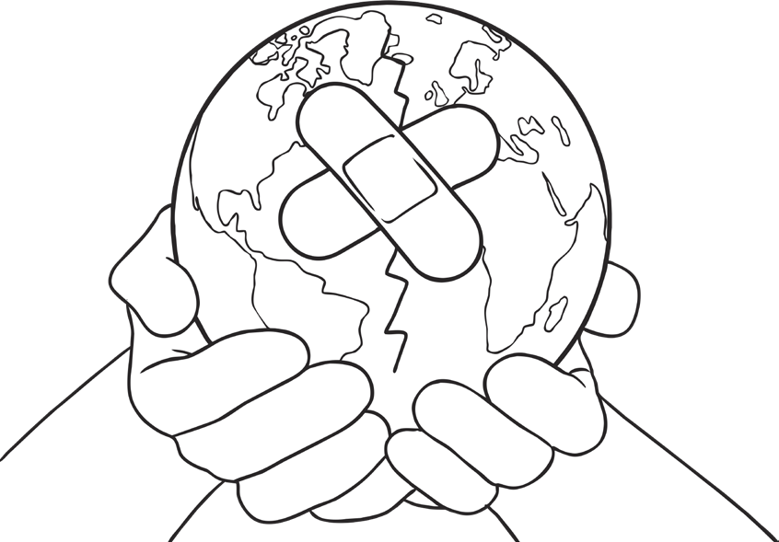
5 Ways I Can Help Our Earth
What could you pledge to do?

