Year 2 English
Friday 29th January 2021

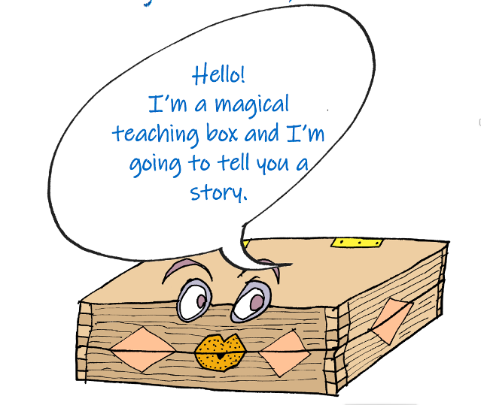
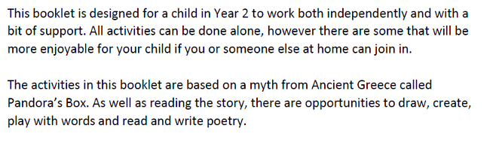

Now, using Kit Wright’s starter line, ‘I will put in the box’, organise your nine ideas into three verses

I will put in the box

I will put in the box

I will put in the box

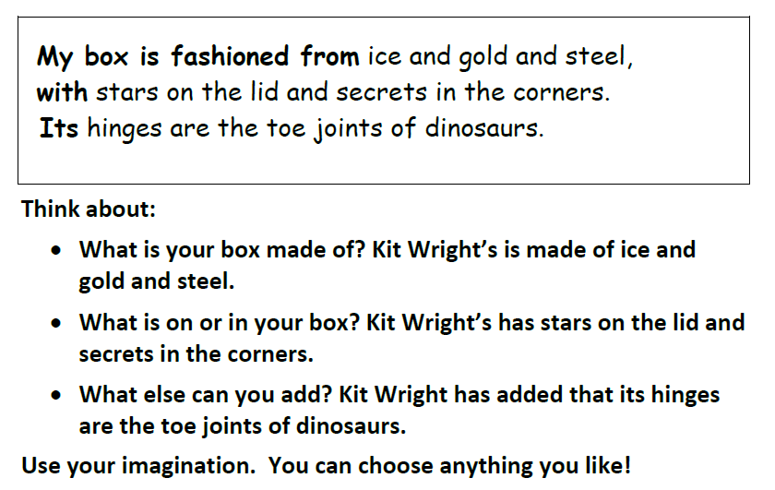

Write the final verse of your magic-box poem here.

