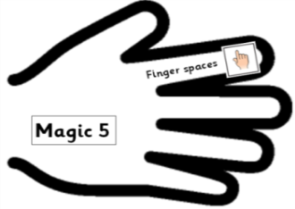 | Date: Tuesday 26th January 2021 | SA
L.O.
To explore compound words.

A Compound word is __________________________________________________________
_________________________________________________________________________
Here are some compound words: (list as many as you can! Use the back of the sheet if you run out of space!)

Write a sentence which includes each of this week’s spellings:
- Dustbin: ______________________________________________________________

- Windmill: _____________________________________________________________

- Playground: ___________________________________________________________

- Nowhere: _____________________________________________________________

- Anywhere: ____________________________________________________________

- Somewhere: ___________________________________________________________

- Beehive: _____________________________________________________________

- Beekeeper: ____________________________________________________________

- Honeycomb: ___________________________________________________________

- Cupboard: ____________________________________________________________

