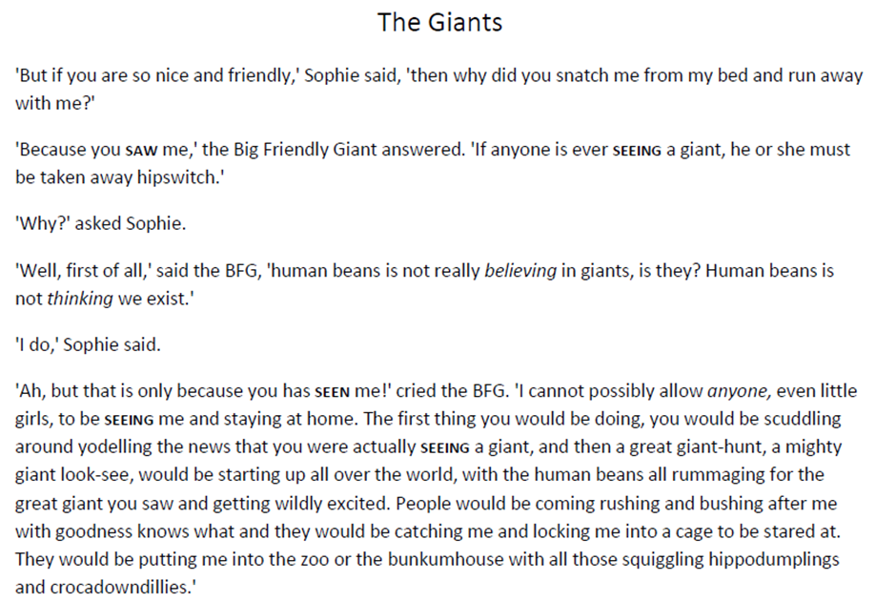
Read back through the first part of the chapter you read yesterday:

- When The BFG speaks he often uses words incorrectly or says words that we don’t use in our language. Go through the text and highlight these words.

- Have a look at the last paragraph of the text. Can you translate it and guess what The BFG meant when he was using these words? Remember your punctuation! I will start it for you…

“Ah, but that is only because you have seen me!” cried The BFG. “I can’t possibly allow anyone, even little girls to see me and stay at home.”

