English Session 3:

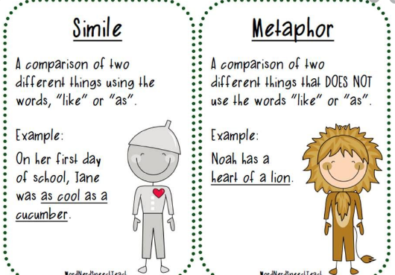
Similes and Metaphors

Task 1:
Are these similes or metaphors?
- I wandered as lonely as a cloud.
- Education is your passport to a good job.
- The moon is like a huge silver balloon.
- His eyes shone like diamonds.
- The sea is a mirror to the clouds.
- Darkness is like a painted day.
- The wind was a whip.
- His ears pop like champagne corks.

Task 2:
Look back at the pictures and words that you have recorded from your BFG session. Can you make any of these descriptions into similes or metaphors? Write them next to the boxes that you drew.

