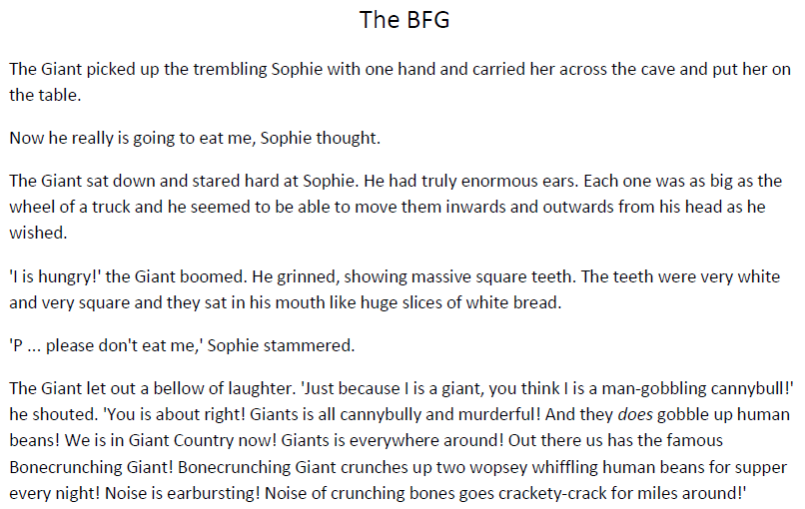
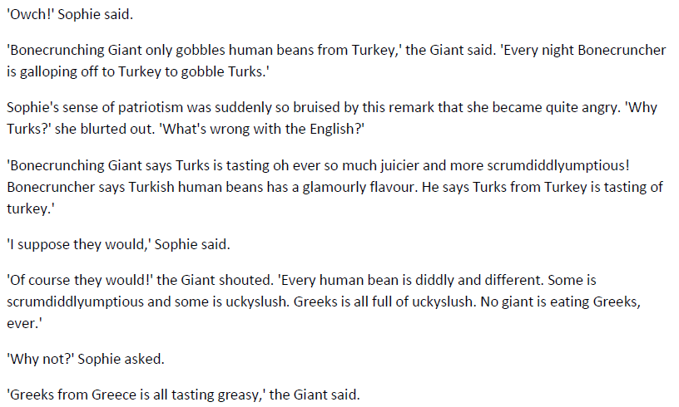

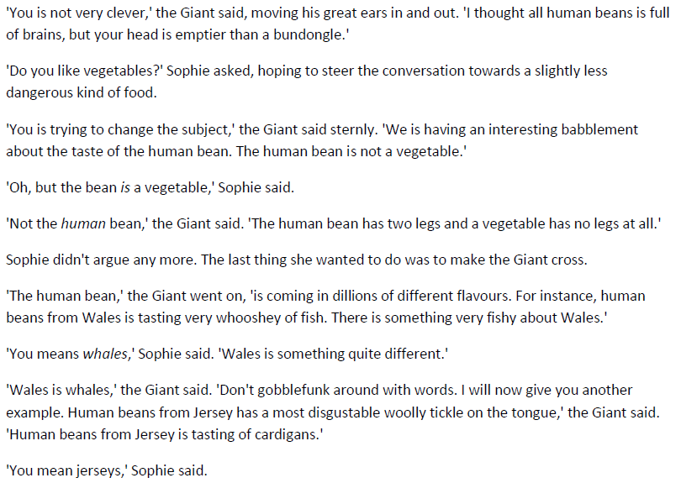
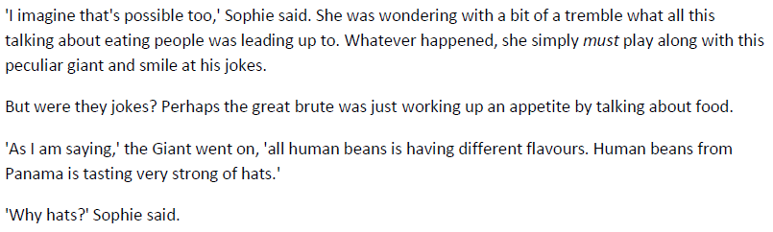

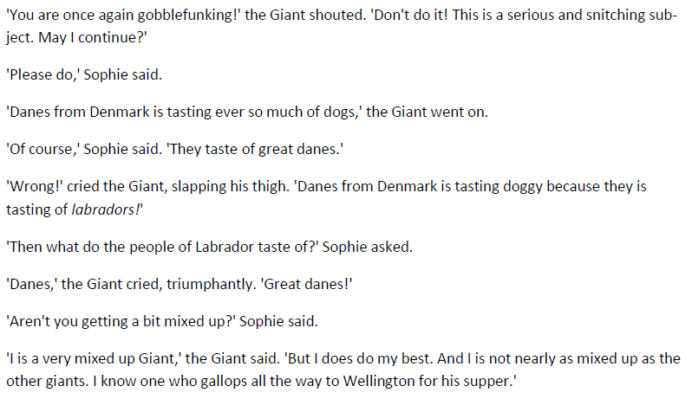
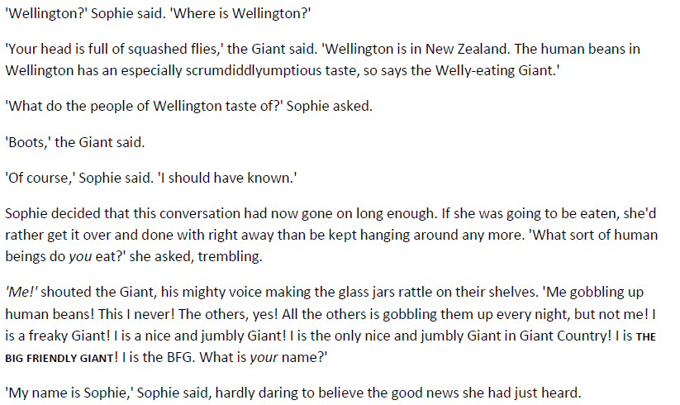

Questions:
- Where did the BFG take Sophie?
- “The giant let out a bellow of laughter.” Why does the author use the word ‘bellow’? What does this tell us about how the BFG laughs?
- What do you think The BFG means when he says ‘human beans’?
- What do the people in Wellington taste of?
- Find a phrase that shows The BFG does not want to eat Sophie.

