English Session 1
Write a character description of the BFG. I would like to see a variety of adjectives (describing words) and some figurative language (such as similes and metaphors).
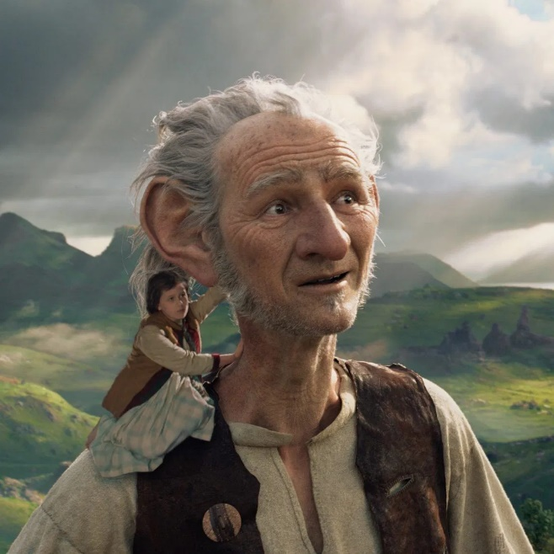
Remember, a character description:
- is not a story. This will only be about 8 sentences describing the character’s appearance and personality.
- is in the present tense.
- will contain full stops, capital letters, commas, apostrophes and possibly parenthesis.

Example: The BFG is a huge man – a giant in fact. Although he is kind, he has an old and grumpy-looking face. His ears are as big as dishes and they struggle to hide behind his grey, wiry hair.

